American University of Sharjah  College of Engineering  Department of Computer Science & Engineering  P. O. Box 26666, Sharjah, UAE |  | Instructors: Dr. Raafat Abu Rukba  Lab Instructor: Praveena Kolli  Office: EB2-126  Phone: 971-6-5152352  e-mail: pkolli@aus.edu  Semester: Spring 2016

COE 420L – Software Engineering I Lab
Lab Assignment - 2

Objectives:
- To export a document from word to DOORS
- To learn to edit modules
- To learn to work with pictures
- To learn about attributes
- To learn about creating and using baselines
- To understand an impact analysis

Steps for using DOORS for:

Export a document from Word into DOORS:

  - In the left pane of the DOORS Explorer, click the project or folder that you want to import the document into. You must have create access to this folder or project.
  - Open Word and open the document you want to send to DOORS.
  - Check for proper formatting. The document must have proper level hierarchy to export to doors

Note: Word 2007 users
- Can change the styles of the text using View - -> Outline and Home - -> Styles
- Can change style area by selecting ALT+ F + I -->Advanced - -> Display (Scroll down) and set style area width and outline to 2cm.f
- Can include different style heading on the menu by Selecting change styles -->Options and check Show next heading when previous level is used.
- Click Tools -> Export to DOORS.

Note: Word 2010/13 Users
- Can change the styles of the text using View - -> Outline and Home - -> Styles
- Can change style area by selecting File -> Options-->Advanced -> Display (Scroll down) and set style area pane width in Draft and Outline views to 1”.
- Click Add-Ins -> Export to DOORS.

Editing:
Creating objects:
At the same level as the current object
- Click Insert -> Object.
One level below the current object
- Click Insert, and then Object Below.

To change the access rights for an object:
The access rights of an object are Read only (R), Create (C) , Modify (M), Delete (D) , Admin (A)
- In the module window, select the object, then right-click Properties.
- Click the Access tab.
- To change rights, Click on ADD
- Check/Uncheck the check boxes for providing suitable rights
- Add users to list you wish to give rights and click OK
To delete an object:
- In the module window, select the object you want to delete, then right-click Edit -> Object -> Delete.
- To make the change permanent (click Edit ->Purge All and save the module).

To undelete an object:
- In the module window, make sure that deleted objects are being displayed.
If necessary, click View -> Show -> Deletions.
- Select the object you want to undelete, and then click Edit -> Object -> Undelete.
Deleted objects have red text, and their change bars are black.
- Save the module (click File -> Save).

To purge an object:
- In the module window, make sure that deleted objects are being displayed.
If necessary, click View -> Show -> Deletions.
- Select the deleted object you want to purge, and then click Edit -> Object -> Purge.
Deleted objects are colored red, and their change bars are colored black.
- You see a message asking if you really want to purge the objects. Click Yes.
- Save the module to make the change permanent (click File -> Save).
The object and all objects in the tree below it are permanently removed from
the database.

Using Attributes:
To show attribute types:
In the module window, click Edit -> Types.

To create an attribute type:
- Make sure you are in exclusive edit mode. The edit mode is shown on the status bar at the bottom of the module window. To change your edit mode, click Edit -> Edit Mode -> Exclusive Edit.
- Click Edit -> Types.
- Either click New to create a new type from scratch, or select the type you want to copy, then click Copy
- Type the name of the new attribute type in the Type name box.
- Select the base type in the Base type box.
- If the base type allows a range of values to be defined, enter the minimum and maximum values in the Minimum value and Maximum value boxes.
- If the base type is Enumeration, click the Enumerations tab, then define the values that attributes of this type can have.
- By default, the new attribute type inherits its access rights from the module.
- Click OK.
- Click Close.
To create an attribute definition:
- Make sure you are in exclusive edit mode. The edit mode is shown on the status bar at the bottom of the module window. To change your edit mode, click Edit -> Edit Mode -> Exclusive Edit.
- Click Edit -> Attributes.
- On the Attributes tab, you see a list of attributes.
- If you want the new attribute to have a type that doesn't already exist, click the Types tab and create the type (see Creating an attribute type).
- On the Attributes tab, either click New to create an attribute from scratch, or select the attribute you want to copy, then click Copy.
- Type the name of the new attribute in the Name box, and select the other options on the General tab.
- By default, the attribute inherits its access rights from the module.
- Click OK.
- Click Close.
- Save the module to make the change permanent (click File -> Save).
To insert a picture/OLE Object:
  - In the module window, select the appropriate object.
  - Click Insert -> Picture/OLE object.
  - In the File name box, type the name of the file that contains the picture, or use Browse to locate it.
  - If you're creating a new object, specify where you want to create it:
Click Same level to create it at the same level as, and immediately after, the current object. You need create access to the current object's parent to do this.
Click One level below to create it one level below the current object. You need create access to the current object to do this.
If the current object already contains a picture, you will see a Replace current picture option on the Insert Picture dialog box.
  - If you want to replace your picture, select the Replace current picture option.
  - Click OK.

Creating a baseline:
To create a baseline, you must have modify access to the module. You can only create a baseline of a formal module.

To create a baseline:
- Make sure you are in exclusive edit mode.
- The edit mode is shown on the status bar at the bottom of the module window. To change your edit mode, click Edit -> Edit Mode -> Exclusive Edit.
- Click File -> Baseline -> New.
- Select None in the Baseline Set list.
- Use the Version radio buttons to select the version number of the new baseline.
- If you want the new baseline to have a suffix as well as a version number, type it in the Suffix box.
- If you want to give the baseline a description, type it in the Description box.
- Click OK.

Viewing a baseline (Creating different versions):
To view a baseline:
- In the module window, click File -> Baseline -> View.
- Select the baseline you want to view, and then click Open.

If the baseline is part of a baseline set, the baseline set to which it belongs is displayed in the Baseline Set box. To see more information about the baseline set, click View.

Understanding impact and traceability analysis:

Impact analysis tells you about out-links.
It displays information about the objects in the chain of links going out from the current module. These are the objects that are affected if you make any changes to the current module.

Traceability analysis tells you about in-links.
It displays information about the objects in the chain of links coming into the current module. Changes to these objects affect the current module.
You can specify how far you want to travel down the chain of linked objects. This is the depth of the analysis.

For example, if you run an analysis with a depth of 2, you see information about the objects that are linked to the objects in the current module, and the objects that are linked to those objects.

Lab Exercises:

Exercise 1

Export TTR word document to DOORS.

Modify the text of the objects against the numbers 3.1.1 and 3.1.2

Delete the object numbered 3.1.5 permanently. (You must use purge).

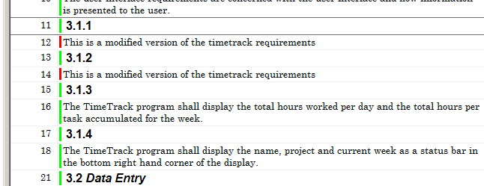

Insert an OLE object Microsoft excel sheet at the object level numbered 3.2.4 that has the following format.
Customer ID | Date | Entry time | Exit time

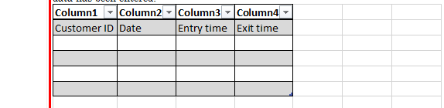

Create an attribute type by name priority that is enumeration has levels High indicated by the red color, Medium indicated by the green color and Low indicated by the blue color.

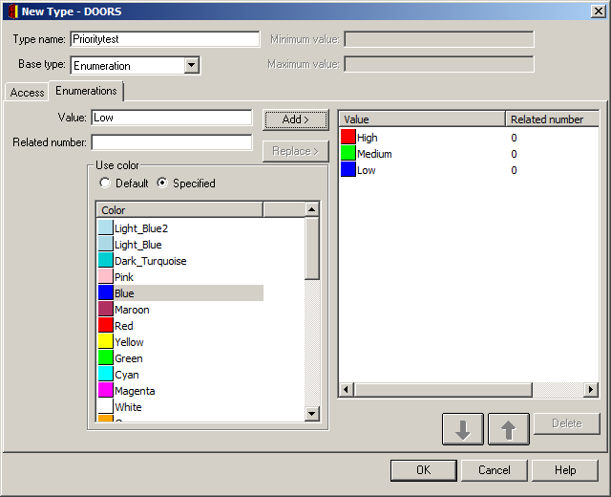

Create a base line

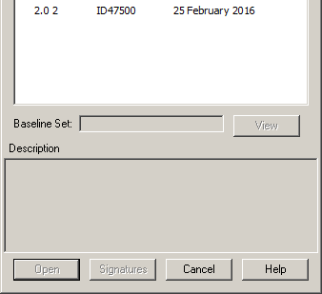

Create links between the objects 3.2.4. (out) and 3.3.5 (in) objects.

Out:

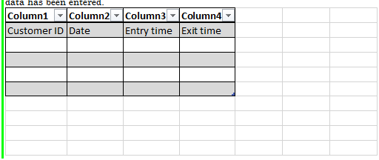

IN:

Show impact analysis of 3.2.4 and traceability analysis of 3.3.5

Exercise 2

Properly format the document named as SRD given in my folder and export it to DOORS

Hand in:
For exercise 1
Attaché activity name, steps involved in that activity and snapshots for exercise 1 that demonstrates the following activities.
  - Exporting word document to DOORS module
  - Insertion and deletion and pugring of objects
  - To insert and delete a picture in a module (Insert under Diagram heading any picture you want )
  - To insert and delete an OLE Object in a module (Insert under OLE Objects)
  - Creating an attribute type , definining and including a new attribute defined, in the module
  - Creating and using a base line
  - Impact analysis
For exercise 2
Attach a copy of the formal module that is created after exporting the word document SRD to it.

